# A Brief History of the Infinity Stones/Gems – Part 1 Early Days

By now half the world has gone to see Avengers Infinity War (a little inside joke there).   The Marvel Cinematic Universe team has done an excellent job setting the stage for the conflict between most of their heroic universe and the Mad Titan Thanos, with the Infinity Stones the central prop in the story.  Also, most people understand that these Stones (or Gems – the term used hereafter for reasons that will become clear) are artifacts of immense power.

But many MCU fans are not readers or collectors of the comics, and several have asked for what back-story, if any, lies behind the Gems and how they were originally conceived in the comics.  Never being one to turn my back on an honest request, I decided to take a break from the current New Gods retrospective to put together a brief history of the Infinity Gems over the next many months, covering additional information about Thanos, Captain Marvel, Adam Warlock, Mistress Death, and other tidbits deemed interesting and important.

The first ingredient in this history of the [Infinity Gems](https://en.wikipedia.org/wiki/Infinity_Gems) is actually found in *Fantastic Four* #67.  In that issue, a cadre of super-scientists (isn’t it always the way) try to make an artificial being that incubates in a cocoon that clearly shows the hand of Jack Kirby.

[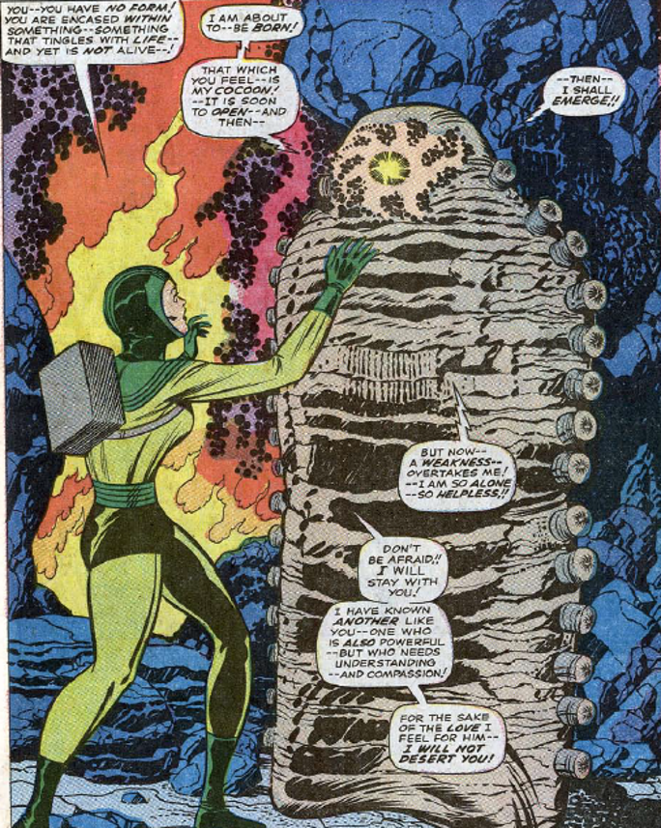](http://aboutcomics.blogwyrm.com/wp-content/uploads/2018/04/Him_is_Born_FF67.png)

When the being finally emerges, he is literally a golden Adonis known only as Him.  Him quickly realizes his creators’ foul intent for him and destroys them without conscience or compunction.

[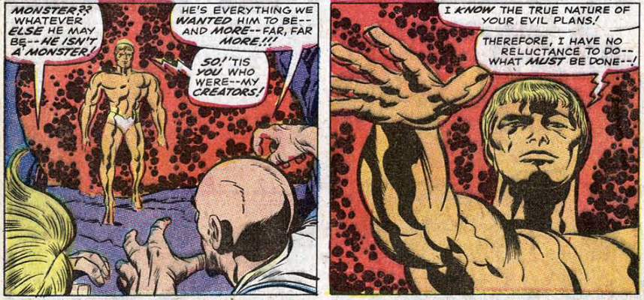](http://aboutcomics.blogwyrm.com/wp-content/uploads/2018/04/Him_Punishes_the_Beehive_FF67.png)

Him then leaves Earth and its sad evil to await a time in which his perfection can fit in with humankind, perhaps a millennium hence.  Unfortunately, Him doesn’t stay true to either his word or his perfect intent.  He soon shows up for a donnybrook with Thor over Lady Sif in issues #165 and #166 (1969) of *The Mighty Thor* but is just as soon forgotten again in the pages of Marvel Comics.

When Him next appears on the scene (*Marvel Premiere* #1, 1972), he is once again in his cocoon continuing his maturation and evolution.  Fittingly, he is picked up by the [High Evolutionary](https://en.wikipedia.org/wiki/High_Evolutionary), who is just about to create a second Earth (called [Counter Earth](https://en.wikipedia.org/wiki/High_Evolutionary#Counter-Earth)) on the far side of the Sun.  This new world would be free of the stain of sin and evil so prevalent in the original.  After over 140 hours of continuous effort, the High Evolutionary, attended by Him still in his cocoon, reaches the culmination of his work with the creation of the new mankind.  Tired by his effort, he dozes and unwittingly allows an earlier creation of his, the purely evil villain named Man-Beast, to spread wickedness into this new world.

Eager to help the High Evolutionary defeat the Man-Beast, Him emerges from his cocoon now bearing a new costume and a new name:  Adam Warlock.

[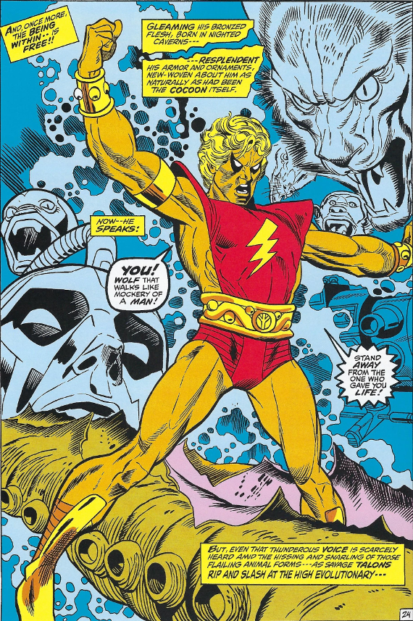](http://aboutcomics.blogwyrm.com/wp-content/uploads/2018/04/Him_Adam_Warlock_Emerges_MP1.png)

Man-Beast flees to Counter Earth to complete his corruption of Paradise.  Seeing that he can neither undo the damage done nor stop the Man-Beast from doing more, the High Evolutionary decides to destroy his new creation.   Warlock begs that Counter Earth be spared and that he be allowed to enter the world and save it from Man-Beast.  The High Evolutionary reluctantly agrees and bestows on him a gem, about which nothing is disclosed in this issue.

[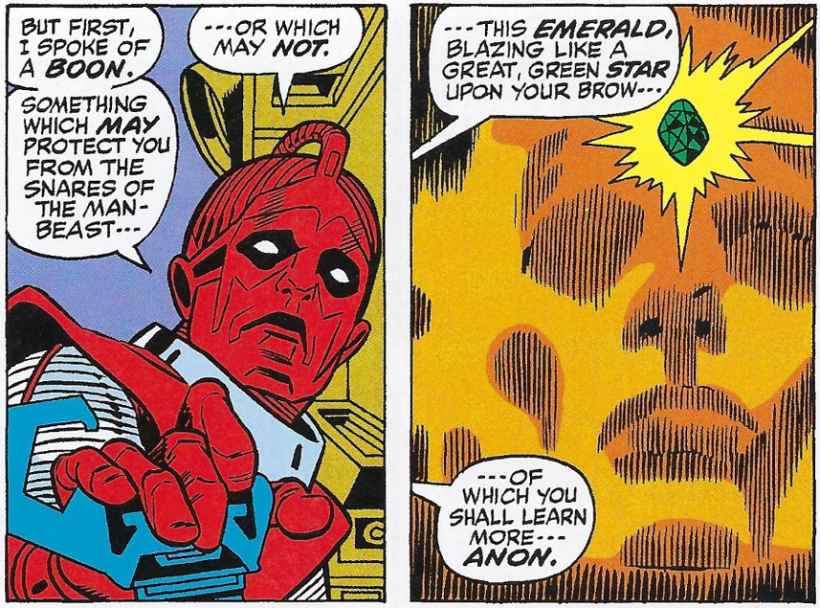](http://aboutcomics.blogwyrm.com/wp-content/uploads/2018/04/Him_Gets_His_Soul_Gem_MP1.png)

Roy Thomas, the author of that story, writes in his introduction to Marvel Masterworks: Warlock Volume 1 how he and Gil Kane revised the costume and name of Him, adding that:

Gil also added that gem on our hero’s brow, just as John Buscema had done for our Vision revamp in ’68; what is it about good artists and gems stuck in their heroes’ foreheads?

This idea of adorning the ‘third eye’ with a gem would be something that get revisited as the gem lore takes shape in the coming 5 years.  But here the ‘emerald’ is still ill-defined and it seems that its powers and abilities are made up as the story went along, usually to provide a deus ex machina ending.

After a second appearance in *Marvel Premiere*, Adam Warlock got his own eponymous title filled with semi-biblical stories following his attempt to be a Christ-like figure on Counter Earth.  The audience must not have been there as the title was soon abandoned and the story-line, complete with a crucifixion and resurrection, was tidied up in *The Incredible Hulk* #176-78.

About 2 years later, Jim Starlin enters the Adam Warlock game with new stories in *Strange Tales* #178-181 (Feb-Aug 1975) followed by a resumption of the old title Warlock #9-15 (Oct 1975-Nov 1976).  Warlock is now in the greater Universe and has encountered a new host of threats and friends – even if he can’t always tell them apart.  Starlin’s approach seems to have been, ‘you take this naïve kid, who may have saved Earth and Counter Earth but is just not quite ready to face the really thorny questions of life, and stick him in the big time where he has to choose amongst a host of bad choices’.

It is within this venue that Starlin begins to flesh out the Infinity Gem lore with the re-introduction of his signature character, Thanos.  The first encounter between Warlock and Thanos takes place through the mediation of another well-known character, Gamora:

[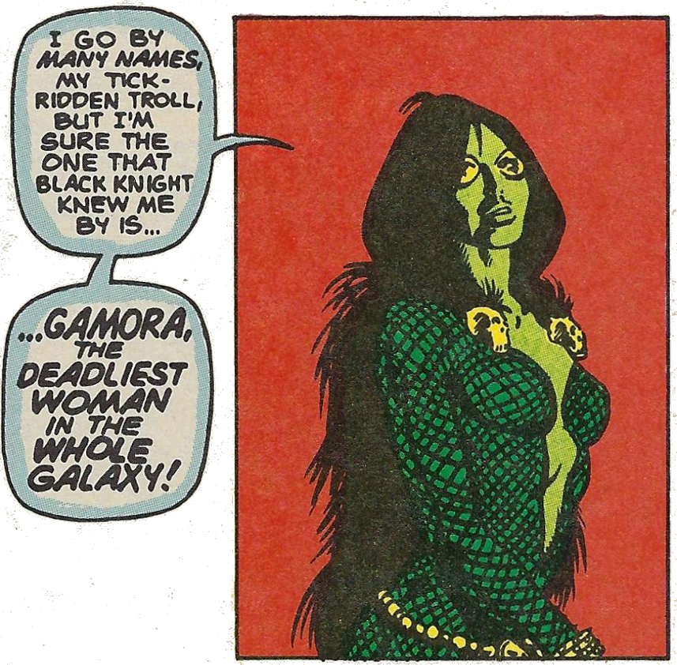](http://aboutcomics.blogwyrm.com/wp-content/uploads/2018/04/Him_Gamora_Introduction_ST181.png)

Details of this storyline will be covered in another post.  Suffice it to say that, with all of the chaos swirling around him, Adam quickly learns not only about his own frailties but also about the sinister nature of his ‘emerald’, now referred to by Starlin as a Soul Gem.

The Soul Gem seems alive and malevolent, often influencing Warlock’s behavior or acting with a mind of its own.

[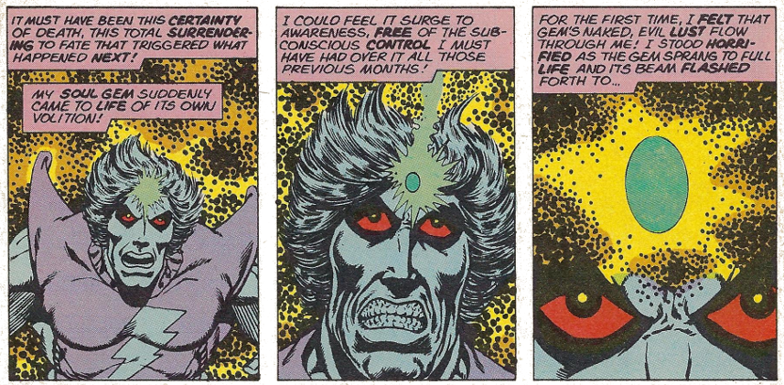](http://aboutcomics.blogwyrm.com/wp-content/uploads/2018/04/Him_Soul_Gem_With_a_Mind_of_Its_Own_ST179.png)

Under Starlin’s direction, Warlock is transformed from the one-dimensional Him to a deeply conflicted multi-layered character, wracked with guilt for allowing the Soul Gem to make him a psychic vampire, disgusted when he wields its power and terrified of what will happen when he doesn’t.

Unfortunately, Starlin’s run on Warlock didn’t last long.  The storyline was closed out in mid-1977 in *Avengers Annual* #7 and *Marvel Two-in-One Annual* #2, but not before some very important layers were added to the Infinity Gem mythology.

*Marvel Team-up* #55, which formed a bridge issue between the Annuals and *Warlock* #15, has Adam returning to Earth via a way-stop on the Moon.  There he encounters Spider-Man and an entity known as the Gardener, who has created a lush garden in the [Blue Area](https://en.wikipedia.org/wiki/Features_of_the_Marvel_Universe#Satellites_and_planetoids).  No sooner do they begin to explore this wonder as the Stranger (originally a Fantastic Four adversary) shows up looking for Warlock’s Soul Gem.

[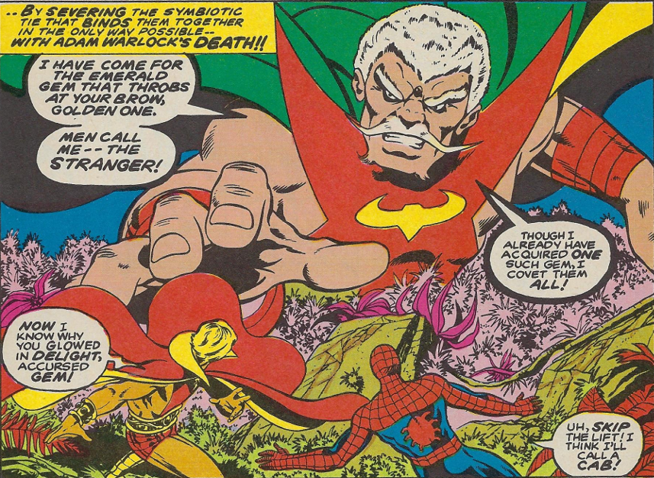](http://aboutcomics.blogwyrm.com/wp-content/uploads/2018/04/Him_Stranger_Wants_the_Gem_MTU55.png)

Eventually the Gardener reveals that he, too, possesses a gem and suggests that the only way they can fend off the Stranger’s attack is a union of the powers of their gems.

[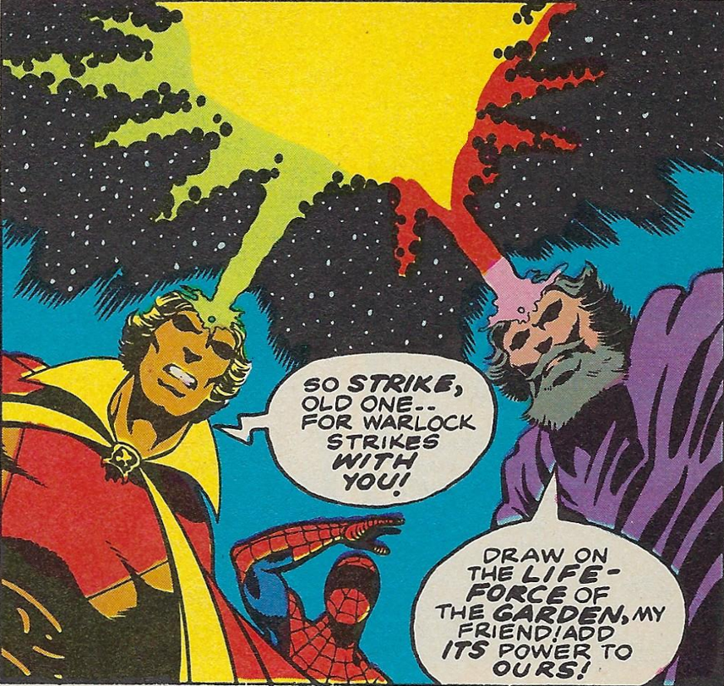](http://aboutcomics.blogwyrm.com/wp-content/uploads/2018/04/Him_and_Gardener_Unite_Their_Gems_MTU55.png)

This issue, written by Bill Mantlo, features the first appearance of additional Soul Gems (six, in fact are mentioned but only two additional ones are seen) and of the Gardener (who is important in the next stage of Infinity Gem lore).  It isn’t known to me whether the ideas for extra gems were Mantlo’s or Starlin’s, but Starlin, as the writer for the final two issues (the annuals mentioned above) makes them central to the storyline.

In *Avengers Annual* #7, Starlin reveals that Thanos had learned that there were 6 Soul Gems spoken of in legend, that he had acquired 5 of them outright,

[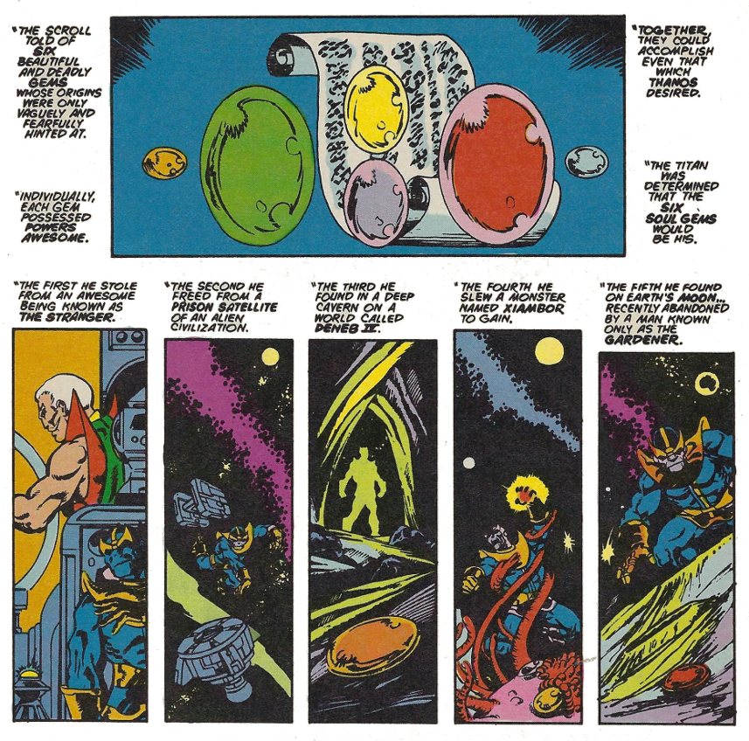](http://aboutcomics.blogwyrm.com/wp-content/uploads/2018/04/Thanos_Soul_Gems_AveAnn7.png)

and that his machinations where Warlock was concerned were designed to get him the essence of the green Soul Gem thus completing the set.  Combining this essence with the essences of the other gems, Thanos made a synthetic seventh gem with which he planned to wipe out the universe star-by-star.

The Avengers, helped by Adam Warlock and Captain Marvel, manage to destroy the seventh gem but, in the process, are captured by Thanos.  Warlock is killed, his soul sucked into his own gem.

The final chapter comes in the *Marvel Two-in-One Annual* #2 where the Thing and Spider-man journey to Thanos’s ship.  The Thing manages to free the Avengers and Captain Marvel but the most important rescue comes from Spider-man when he is able to liberate Warlock’s soul from the Soul Gem.

[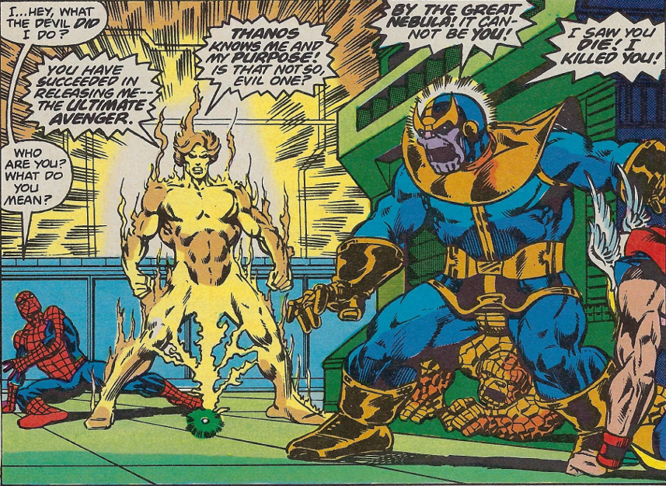](http://aboutcomics.blogwyrm.com/wp-content/uploads/2018/04/Him_Adam_Released_MTIOAnn2.png)

In his ethereal form, Adam Warlock quickly brings an end to the Mad Titan’s existence turning him to solid granite.

[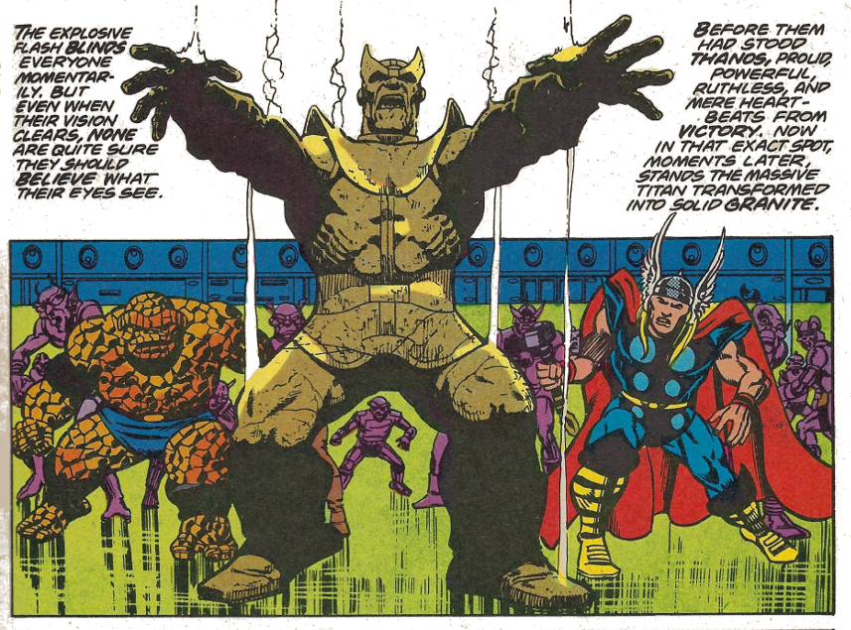](http://aboutcomics.blogwyrm.com/wp-content/uploads/2018/04/Thanos_Dies_MTIOAnn2.png)

And so he remained until 1990 when he is sent back from the land of the dead armed with the real knowledge of the Soul Gems – but this is the subject of next month’s post.